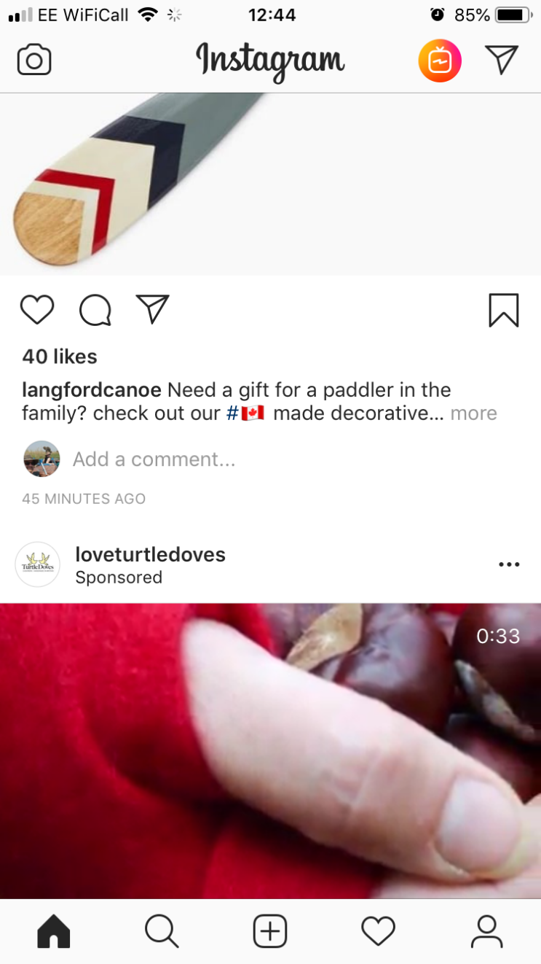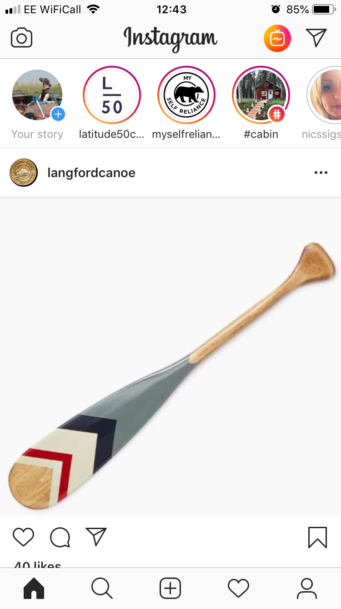

**Virtually Visiting World Heritage Sites**



You’re going to sketch an imaginary Instagram post.

In the circle sketch your profile picture and add a profile name (this can be made up)

In the large square you’re going to sketch a picture of a world heritage site (any at all around the world that you choose) you could add yourself to the picture or do it like a selfie.

If you’re brilliant with photoshop or picture editing you could mock one up.

In the bottom square write a caption for the image – make sure you say which World Heritage Site you are ‘visiting’. What would you put? What is a world heritage site? What # might you include?

For our project we are using

#GreatPlaceScheme  
#DerwentValleyMillsWHS

@DVMillsWHS and @HeritageFundM_E

***Feel free to post about this project on social media using these!***

