Gathering Inspiration

AS you explore gather

WORDS, FACTS, THOUGHTS, FEELINGS, SKETCHES, RUBBINGS, PHOTOS

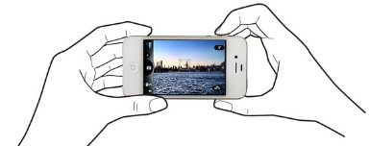MCj02979350000[1]

Sights

Tastes

Touch

Feelings

Smells

Sounds