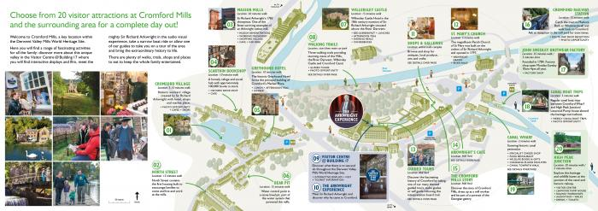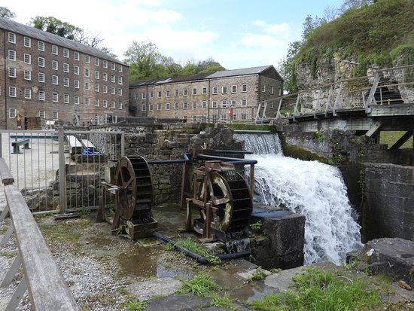

General observations – What caught your eye?

What / where would you like to explore more in this place?

What might you make, inspired by this place?

Cromford Mills

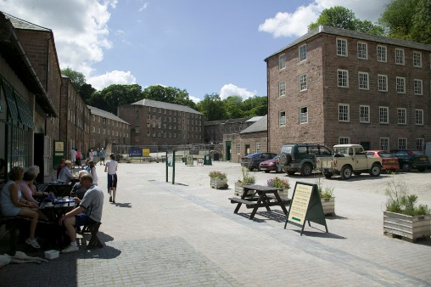

What questions do you have about this site?

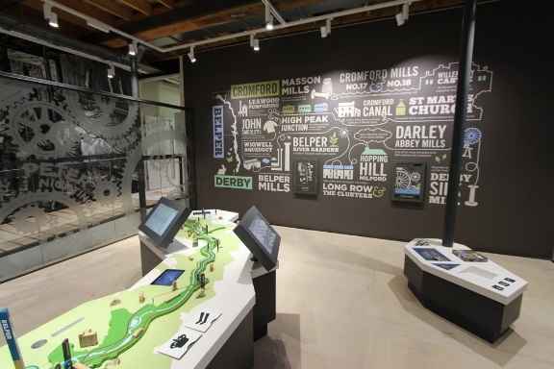

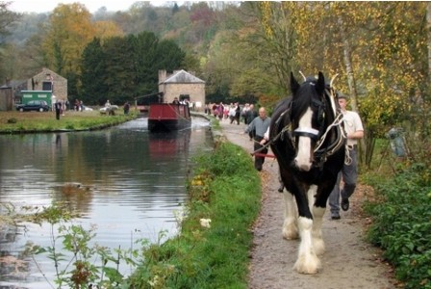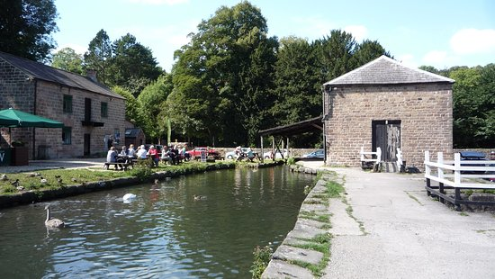

General observations – What caught your eye?

What / where would you like to explore more in this place?

What might you make, inspired by this place?

Cromford Canal

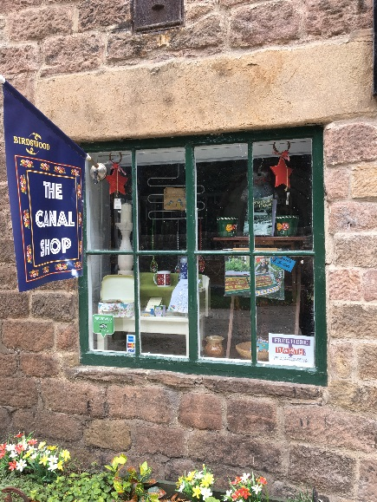

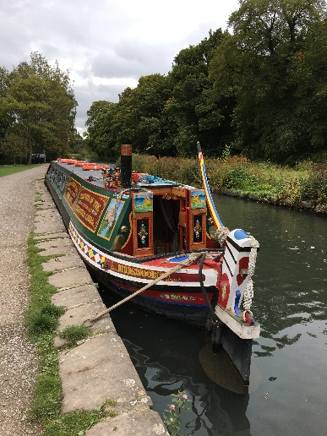

What questions do you have about this site?

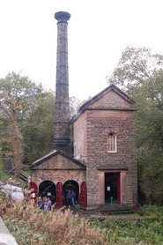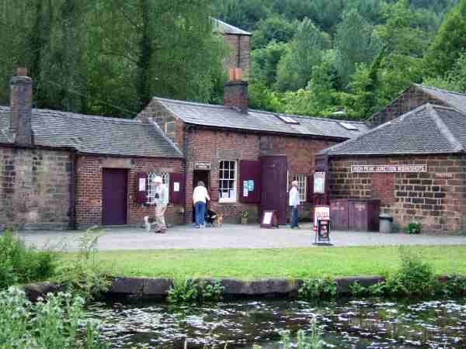

General observations – What caught your eye?

What might you make, inspired by this place?

What / where would you like to explore more in this place?

High Peak Junction and Leawood Pumphouse

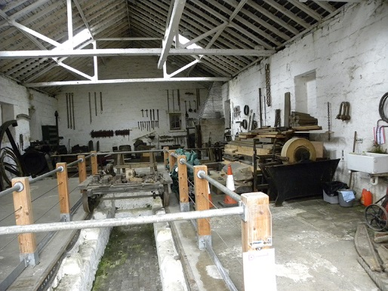

What questions do you have about this site?

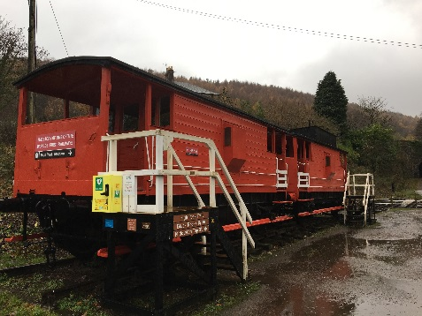

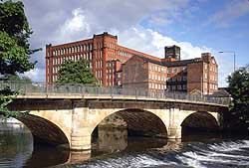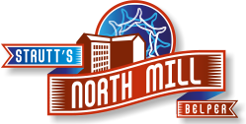

General observations – What caught your eye?

Belper Mills

What / where would you like to explore more in this place?

What might you make, inspired by this place?

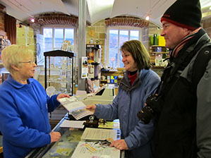

What questions do you have about this site?

